RECRUITMENT INFORMATION PACKAGE

CUSTOMER SERVICE OFFICER – INFORMATION MANAGEMENT

For further information contact: Linda McNab
Human Resources Coordinator Phone: (08) 9339 9339
or
email: recruitment@eastfremantle.wa.gov.au

Written Applications must be received by: 4pm Tuesday 4th May 2021
Information Package: CSO – Information Management

Contents
For further information contact: Linda McNab 1
Written Applications Must Be Received by: 4pm Tuesday 4 May 2021 2
1. Advertisement 4
3. Conditions of employment 3
4. Other benefits of working at Town of East Fremantle 3
5. Information on the Town of East Fremantle 4
6. Strategic Community Plan 2020 - 2030 4
7. Application Process 5
7.1 Required Documents 5
7.2 Referees 6
7.3 Formal qualifications 6
7.4 Selection for interview 6
7.5 During the interview 6
7.6 Additional Assessments 6
7.8 Interview Outcomes 7
7.9 Submitting your application 7
8. Position Description 8

Advertisement

Customer Service Officer – Information Management

Are you looking for an opportunity to be part of an innovative Council? As a member of the Town of East Fremantle’s team, this role provides an opportunity to make a difference in a very picturesque part of the world, with a strong heritage base.
This permanent full-time appointment reports to the Coordinator Customer Service and Information Management and will provide quality customer service, records and information management functions in an efficient and effective manner that maintains and nurtures relationships with stakeholders, and represents the Town in a professional manner at all times.
The current salary range is $62,000 – $65,000 depending on experience, plus up to 14.5% superannuation, a rostered day off once a month, and other Town-focused benefits such as free parking, and health and well-being initiatives.

The Town of East Fremantle promotes a workplace that actively seeks to include, welcome and value unique contributions of all people. The Town encourages people of all ages, genders, and abilities, Aboriginal Australians and people from culturally diverse backgrounds to apply for this job.

To obtain an application package please go to our web page - http://www.eastfremantle.wa.gov.au/council/employment-at-the-town-of-east-fremantle.aspx. For further information about the position, please contact Linda McNab, Human Resources Coordinator on 9339 9339 or email recruitment@eastfremantle.wa.gov.au.
Applications must be submitted by 4.00pm Tuesday 4 May 2021.

Gary Tuffin
Chief Executive Officer

Information Package: Community Engagement Officer

- Organisation Structure
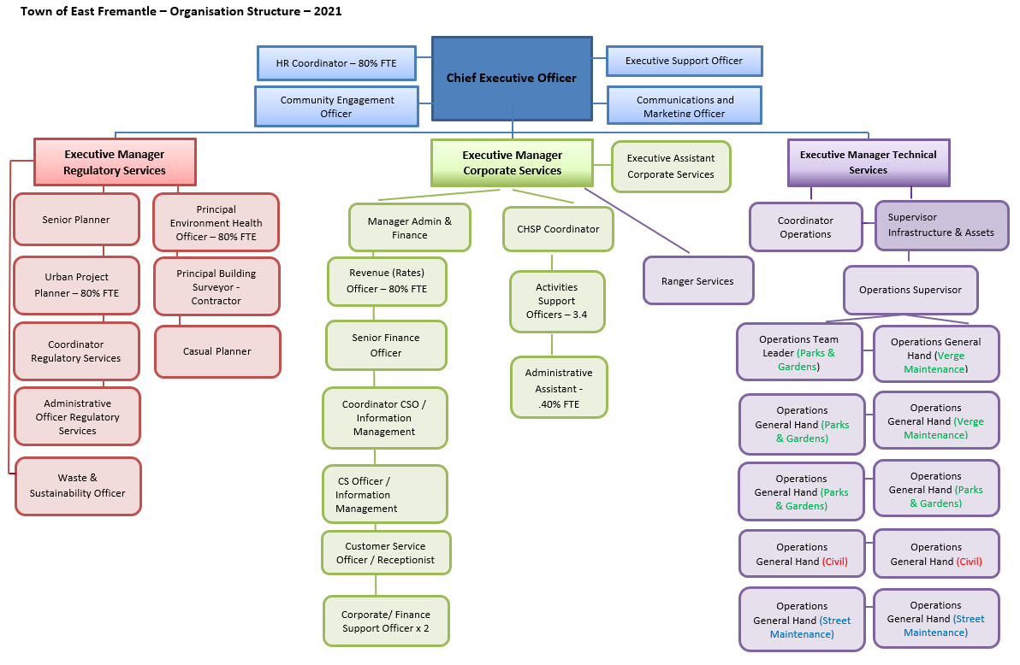

Conditions of employment

- This is a permanent position, with a three (3) month probationary period.

- Council will contribute 9.5% compulsory superannuation and you will be eligible to enter into Council’s contributory scheme (entitles you to further contributions up to 5% of salary), depending on conditions.

- Working Hours – 8:30am – 5.00 pm (1/2 lunch break) Monday to Friday. A minimum of eight (8) hours per day, seventy-six hours (76) hours per fortnight.

- One rostered day off every month.

- Annual Leave – four (4) weeks per annum.

- Training and personal development opportunities.

- Clothing allowance – in accordance with Council policy.

Other benefits of working at Town of East Fremantle

Employee Benefits: In addition to the salary range indicated above, the Town offers an extensive range of benefits which includes:
  - Flexible working hours for a work life balance;

  - Parental Leave as per the National Employment Standards;

  - Thirteen (13) weeks paid long service leave after ten (10) years continuous service;

  - Free parking; and

  - Health and wellbeing program.

Information on the Town of East Fremantle

The Town of East Fremantle was created in 1897, when it separated from the Fremantle Municipal Council. Bordering the Swan River, our Town has a strong cultural heritage and supports a large range of sporting clubs and community organisations.

The Council comprises the Mayor and eight (8) Councillors, providing representation for a resident population of approximately 8,189 and covering 3.2sq kilometres.

The Town’s administration centre is located at 135 Canning Highway East Fremantle and has been fully refurbished to accommodate Finance and Administration, Town Planning and Building, Environmental Health and Community Services. The Depot is located at 59 Allen Street, East Fremantle behind the East Fremantle Bowling club.

The Town has approximately 60 employees, with a total budget of approximately $10.5 million.

Strategic Community Plan 2020 - 2030

The Strategic Community Plan is a long-term planning document that sets out the community’s vision, aspirations for the future, and the key strategies we will need to focus on to achieve our aspirations.

It is part of our fulfilment of the Integrated Planning and Reporting (IPR) Framework. All local governments in Western Australia are required to implement IPR which enables robust decision- making. Our current plan is now being reviewed via a process of community consultation.

A copy of the Plan can be found on our website

Application Process

Selections will be based on which applicant demonstrates the highest merit for the position and on their past experience and ability to demonstrate that they can perform the duties in the advertised position.

7.1 Required Documents

Please provide the following documentation:
- Covering Letter
Please provide a covering letter with your application.

- Curriculum Vitae/Resume
This should provide personal details (e.g. name, address, telephone number) relevant work history, education, training courses attended, qualifications and professional memberships.

- Statement addressing the Selection Criteria
To apply, please submit a statement (in 3 pages or fewer using font no larger than 11 point) that addresses all of the selection criteria. The statement should demonstrate that the applicant has the relevant skills, experience and suitability for the position in the context of the role statement. Selection Criteria can be found in the position description.

Please note – proforma applications cannot be accepted.

7.2 Referees

You should include in your Resume the names and contact numbers of at least two (2) referees. These referees may be contacted to verify the information stated in your Resume. We prefer that your referees be a current manager / supervisor; however a manager / supervisor from a previous position may be used.

7.3 Formal qualifications

The position description addresses whether formal qualifications are a requirement. If required, photocopies of your qualification(s) or academic records of current studies should be attached to your application. Please do not submit originals.

7.4 Selection for interview

A shortlist of applicants for interview will be chosen by a selection panel. To be shortlisted applicants must demonstrate that they meet the requirements for the position. Shortlisting may take up to two weeks after the closing date.

If your application is shortlisted, you will be invited for an interview. All interview questions will be based on the selection criteria for the position and in most cases, will be given to you shortly before the interview.

Unsuccessful applicants at this stage will be notified in writing. If you do not receive any correspondence from the Town of East Fremantle within three (3) weeks of the closing date, please assume that your application was unsuccessful in this instance.

7.5 During the interview

Applicants with special requirements, such as wheelchair access, are requested to inform the officer when asked to attend for an interview.

Each interview will be conducted by an interview panel and each applicant will be assessed in the same manner. The aim is to obtain examples of past situations that actually occurred, how the situation was handled and the outcome of the action taken. During the interview, panel members will take notes and assess your answers to questions.

Do not assume that each panel member knows your suitability for the role, even though you may have worked with them, or have previous experience in the position you have applied for.

Should you not understand a question asked during the interview please seek clarification prior to providing a reply. Feel free to ask questions of the panel relevant to the position and the organisation, as the interview is a two-way communication process.

7.6 Additional Assessments

Preferred applicants may be required to undertake a pre-employment medical to determine the applicant’s suitability to carry out the inherent requirements of the position description.
The preferred applicants will also be required to provide a current Police clearance (the cost of such will be reimbursed).

In some instances a second informal interview may be required.

7.8 Interview Outcomes

All shortlisted candidates will be contacted within seven (7) working days of the interview.

The successful candidate will be offered the position verbally from the panel Chairperson or the Human Resources Coordinator while unsuccessful candidates will be notified in writing.

If requested, the panel Chairperson will provide feedback to unsuccessful applicants who received an interview, indicating the reasons why their application was not successful.

7.9 Submitting your application

Applicants are requested to forward their application one of the following ways:

Delivered by hand, addressed to: | or by post and should be addressed to: | or via email – please save in Word or PDF
Gary Tuffin | Gary Tuffin | Gary Tuffin
Chief Executive Officer | Chief Executive Officer | Chief Executive Officer
Town Hall, 135 | PO Box 1097 | Town of East Fremantle
Canning Highway | FREMANTLE | recruitment@eastfremantle.wa.gov.au
EAST FREMANTLE | WA 6959
WA 6158

Position Description

HR PD - Customer Service Officer – Information Management

Position identification
Position number | ADMIN
Classification | Level 7 | Plus over award
Position title | Customer Service Officer – Information Management
Directorate | Corporate Services
Business unit | Customer Service
Service area | Customer Service
Location | Town Hall
Agreement | Local Government Award
Status | Continuous
FTE | 100% |  | Hours p/week | 38
Position created | April 2021 |  | Last review | April 2021

Reporting relationship
Executive Manager Corporate Services

Coordinator Customer Service and Information Management

Customer Service Officer – Information Management

TOWN OF EAST FREMANTLE CORE VALUES – DOING THINGS THE RITE WAY
- Respect – Being courteous at all times and valuing the views and opinions of others by having due regard to their rights and responsibilities.
- Integrity – Holding oneself to consistent standards exemplified by being honest and having a strong moral code, upholding the reputation of the organisation.
- Teamwork – Working together to achieve agreed outcomes by building and sustaining a high performance work environment underpinned by trust and commitment.
- Empathy – Willing to develop an understanding of someone’s concerns and consider their needs and feeling sin working with them to address work related issues and solve problems.

Corporate Key Performance Areas outlined in:
- Strategic Community Plan
- Corporate Business plan
- Performance appraisal action plan
Primary objectives of the position
- To provide quality customer service, records and information management functions in an efficient and effective manner that maintains and nurtures relationships with stakeholders, and represents the Town in a professional manner at all times.
- Ensure efficient and effective customer services and information management for the Town of East Fremantle.
- Contribute to ensure the Town meets its statutory obligations in a timely manner and in particular, to ensure compliance with the Town’s Record Keeping Plan and the State Records Act 2000;
- To assist in the development and implementation of an effective and efficient knowledge management framework for the Town; and
- Contribute to the development, implementation and achievement of the Town’s Business Plan.
Key Competencies
- Customer service  - Job knowledge  - Process improvement  - Self-management and initiative  - Communication  - Community engagement | - Strategic  - Interpersonal skills  - Quality of work  - Professionalism  - Teamwork

Key Responsibilities and Duties

Customer Service
- Provide a high level of customer service both internally and externally, in line with the standards of the customer service charter.
- Develop an understanding and knowledge of the organisational structure and functions to ensure accurate re-direction of customer requests and delivery of information to relevant officers to ensure the provision of efficient customer and records services.
- Ensure visitors and guests are dealt with in a professional manner, and with courtesy and respect.
- Liaise with managers and staff to ensure that information provided to customers is accurate, timely and informative.
- Liaise with officers across the organisation to ensure that customer objectives and expectations are being met, utilising feedback to identify and implement system or process improvements in particular to benefit the organisation.
- Monitor and manage day-to-day operational activities and workflow.
- Manage and monitor effective customer complaint handling and complaint resolution processes, in accordance with policy and procedures.
- Ensure all incoming calls and queries relating to all service areas are processed in a timely and efficient manner.
- Ensure currency of website information.
- Responsible for updating Front Desk information screen.
- In conjunction with other Support Officers develop FAQ’s and fact sheets.
Finance
- Ensure that all monies are processed, receipted and reconciled accurately, and with the appropriate documentation to undertake the banking when required ensuring security and an overall duty of care in the handling of cash.
Information Management
- Provide quality / timely research and information retrieval services to enable staff and Council to make informed business decisions.
- Lead the development, implementation, monitoring and review of strategies, policies and procedures for records management, including the establishment of key performance indicators that will meet the current and future needs of the Town.
- Ensure that records are registered, maintained, archived and disposed of, in compliance with the provisions of the State Records Act 2000.
- Assist to ensure the Records Keeping Plan is regularly reviewed and updated in accordance with the State Records Act 2000.
- Assist to undertake the appropriate research, correspondence and actions associated with Freedom of Information requests ensuring compliance with the Freedom of Information Act 1992, and other legislation such as the Local Government Act 1995.
- Assist in the maintenance of the newspaper cuttings books to ensure appropriate evidence can be sourced for public and state-wide notice requirements.
- Assist in the research required in order to recommend and develop a leading practice knowledge management framework for the Town.
- Assist in the development, implementation and review of knowledge management strategies, policies and practices across the organisation to improve how information and knowledge is stored, accessed and shared.
- Assist in the development and implementation of knowledge sharing systems and processes for the organisation, including training of staff so they can continually maintain these in the future.
- Provide information and systems support to internal projects such as the Names and Addresses, Customer Service Request System and Business software applications.
- Comply with relevant legislation regarding documentation and record keeping.
- Undertake quality audits as requested.

Information Technology Support
- Assist in troubleshooting technology issues with mobile devices and tablets for staff
- Provide induction training on basic access, security and general system features.
- Liaise with the Council’s telephone providers to maintain effective telephone and mobile telephone services and support.
- Arrange for the purchase of computing and communication (telephone) consumables.
- Other IT duties as requested.
Governance
- Actively contributing to business planning activities, including developing, monitoring and review, with a focus on the principles of continuous improvement and risk management.
- Ensure best practice sound record keeping compliant with legslative requirements, and supports the use of the Customer Srevice Moduile.

- Adhere to the Town’s policies, procedures, Code of Conduct and Occupational Safety and Health Responsibilities.
Other
Perform other duties as directed when appropriate to the scope and level of this position.
- Participate in the Performance Review and Assessment process.
- Undertake development and training as agreed for career and personal development initiatives.
- Provide specialist records management advice and training to Elected Members and Town staff on a regular basis.

Selection criterial
Essential
- Highly developed written and verbal communication skills
- Advanced computer skills and attention to detail at all times;
- Demonstrated ability and strong commitment to customer service with a desire to raise the profile and perception of the Town within the community;
- Demonstrated understanding of records management processes and procedures including usage of office equipment;
- Experience in records management or information management;
- Demonstrated ability to work within a team environment, participate in activities and support all team members;
- Ability to recognise issues and use initiative to identify and discuss proposed solutions;
- Ability to work under limited direction to improve and enhance processes and practices, and achieve high quality results by taking a shared responsibility for setting priorities, organising workloads and meeting prescribed or self-imposed deadlines in a team environment.
- Experience with IT Vision Synergy Soft software;
- Previous experience in Information Technology.
Desirable
- Previous experience in a similar position within Local Government, or a qualification and/or extensive experience in any of the relevant field would be highly regarded.
- Understanding of financial processes and procedures.

Other specific details of the position
Extent of authority | This position operates under broad direction but within limits of Town policy and relevant legislative constraints.
Position has purchasing authority in line with procedure |  |  |  | No

Certification
1. The details contained in this document are an accurate statement of the duties, responsibilities and other requirements of the job.

Manager’s signature |  | Date
2. As position holder I have noted the statement of duties, responsibilities and other requirements as detailed in this document.

Position holder’s signature |  | Date

