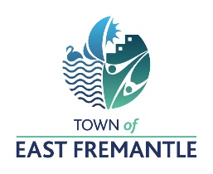

REQUEST FOR TENDER

RFT 05-2021/2022
EAST FREMANTLE OVAL REDEVELOPMENT
QUANTITY SURVEYING SERVICES

The Town of East Fremantle is seeking Tenders from suitably qualified Quantity Surveying firms for the provision of cost consultancy services in the delivery of the East Fremantle Oval Redevelopment.

A copy of the tender documentation can be obtained by emailing:
tenders@eastfremantle.wa.gov.au

Tender responses may be submitted by hand to the Town of East Fremantle, Town Hall, 135 Canning Highway, East Fremantle or electronically via the tender email: tenders@eastfremantle.wa.gov.au

Tenders must be received before the deadline of 4pm on Friday 22 October 2021 clearly marked with the Tender Reference. Late Tenders will not be accepted.

Gary Tuffin
CHIEF EXECUTIVE OFFICER

