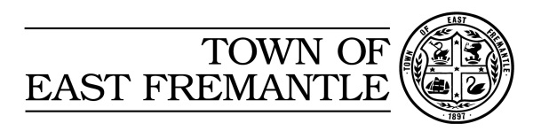
2017/18
Community Grants and Sponsorship Process

When |  | What you need to do
January - March 2017 |  | Consider the project/event application that you would like to submit for the following financial year – with a project plan and budget prepared where applicable
March/April 2017 |  | Community grant/Sponsorship Applications open. Guidelines and Application Forms will be available 8\  n the Town’s website and emailed to community and sporting groups.  For more information email the Town via  admin@eastfremantle.wa.gov.au
May 2016 |  | Application close at 4.00pm on Monday 1 May 2017.  Late applications cannot be considered.
All applications will be presented to Council for their consideration. You will be advised, in writing of the outcome of these deliberations once the budget has been adopted. Along with notification, successful applicants will receive details on how to claim their payment – noting that any previous monies received from Council must be acquitted prior to the release of this payment.
(May 2017) |  | Complete you project and submit your payment claim/acquittal with the requested supporting documents – receipts, photos, examples of media coverage.

